|  |  |
| --- | --- |
| Experiment Number:07 | **07** |
| **Title: Performing VLAN and Inter - VLAN Configuration using cisco packet tracer.** |
| ▪ |  |

**Second Year Advanced Computer Networking**

Objectives:

1. To learn VLAN and Inter VLAN communication and configuration.

Theory

Virtual LANs (VLANS) are networks segments on a switched LAN. Inter-VLAN routing refers to the movement of packets across the network between hosts in different network segments.

VLANs make it easier for one to segment a network, which in turn improves the performance of the network and makes it more flexible, since they are logical connections.

VLANs act as separate subnet on the network. To move packets from one VLAN to another and enable communications among hosts, we have to configure the VLAN network.

**Topology:-**

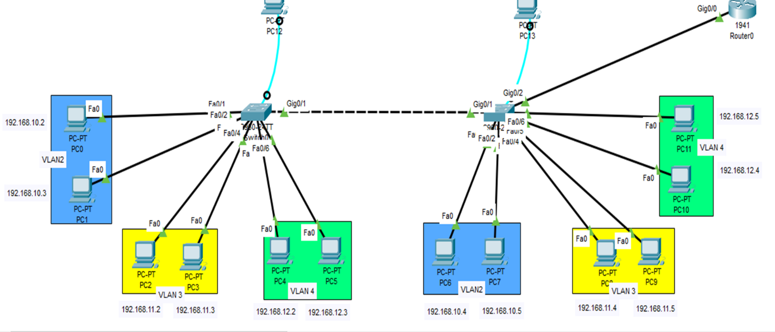

**Connections:-**

**Assign IP addresses: ---**

PC0:- 192.168.10.2

PC1:- 192.168.10.3

PC2:- 192.168.11.2

PC3:- 192.168.11.3

PC4:- 192.168.12.2

PC5:- 192.168.12.3

PC6:- 192.168.10.4

PC7:- 192.168.10.5

PC8:- 192.168.11.4

PC9:- 192.168.11.5

PC10:- 192.168.12.4

PC11:- 192.168.12.5

**VLAN configuration**

**Switch 0**

* Switch(config)#vlan 2
* Switch(config-vlan)#name IT
* Switch(config)#vlan 3
* Switch(config-vlan)#name CS
* Switch(config)#vlan 4
* Switch(config-vlan)#name ADMIN

Switch(config)#interface fastEthernet 0/1

Switch(config-if)#switchport mode access

Switch(config-if)#switchport access vlan 2

Switch(config)#interface fastEthernet 0/2

Switch(config-if)#switchport mode access

Switch(config-if)#switchport access vlan 2

Switch(config)#interface fastEthernet 0/3

Switch(config-if)#switchport mode access

Switch(config-if)#switchport access vlan 3

Switch(config)#interface fastEthernet 0/4

Switch(config-if)#switchport mode access

Switch(config-if)#switchport access vlan 3

Switch(config)#interface fastEthernet 0/5

Switch(config-if)#switchport mode access

Switch(config-if)#switchport access vlan 4

Switch(config)#interface fastEthernet 0/6

Switch(config-if)#switchport mode access

Switch(config-if)#switchport access vlan 4

**Switch 1**

* Switch(config)#vlan 2
* Switch(config-vlan)#name IT
* Switch(config)#vlan 3
* Switch(config-vlan)#name CS
* Switch(config)#vlan 4
* Switch(config-vlan)#name ADMIN

Switch(config)#interface fastEthernet 0/1

Switch(config-if)#switchport mode access

Switch(config-if)#switchport access vlan 2

Switch(config)#interface fastEthernet 0/2

Switch(config-if)#switchport mode access

Switch(config-if)#switchport access vlan 2

Switch(config)#interface fastEthernet 0/3

Switch(config-if)#switchport mode access

Switch(config-if)#switchport access vlan 3

Switch(config)#interface fastEthernet 0/4

Switch(config-if)#switchport mode access

Switch(config-if)#switchport access vlan 3

Switch(config)#interface fastEthernet 0/5

Switch(config-if)#switchport mode access

Switch(config-if)#switchport access vlan 4

Switch(config)#interface fastEthernet 0/6

Switch(config-if)#switchport mode access

Switch(config-if)#switchport access vlan 4

**Router connection**

Router(config)#interface gigabitEthernet 0/0

Router(config-if)#no ip address

Router(config-if)#no shutdown

Router(config)#interface gigabitEthernet 0/0.2

Router(config-subif)#encapsulation dot1Q 2

Router(config-subif)#ip address 192.168.10.1 255.255.255.0

Router(config)#interface gigabitEthernet 0/0.3

Router(config-subif)#encapsulation dot1Q 3

Router(config-subif)#ip address 192.168.11.1 255.255.255.0

Router(config)#interface gigabitEthernet 0/0.4

Router(config-subif)#encapsulation dot1Q 4

Router(config-subif)#ip address 192.168.12.1 255.255.255.0

**Configure Trunk port:**

What does trunk mean in networking? A trunk is a single channel of communication that allows multiple entities at one end to correspond with the correct entity at the other end. It is a “link” that carries many signals at the same time, creating more efficient network access between two nodes

**Switch 0:-**

Switch(config)#interface gigabitEthernet 0/1

Switch(config-if)#switchport mode trunk

**Switch 1:-**

Switch(config)#interface gigabitEthernet 0/1

Switch(config-if)#switchport mode trunk

**Switch 1:-**

Switch(config)#interface gigabitEthernet 0/2

Switch(config-if)#switchport mode trunk